Project 2

Eat -A- Freash

* Anthony Fatato, Telahoun Molla, Anthony Moonen, Emma LaPalm
* Our proposal for project 2 is an app that allows gardeners to sell excess produce to local buyers. An online farmers market.
* 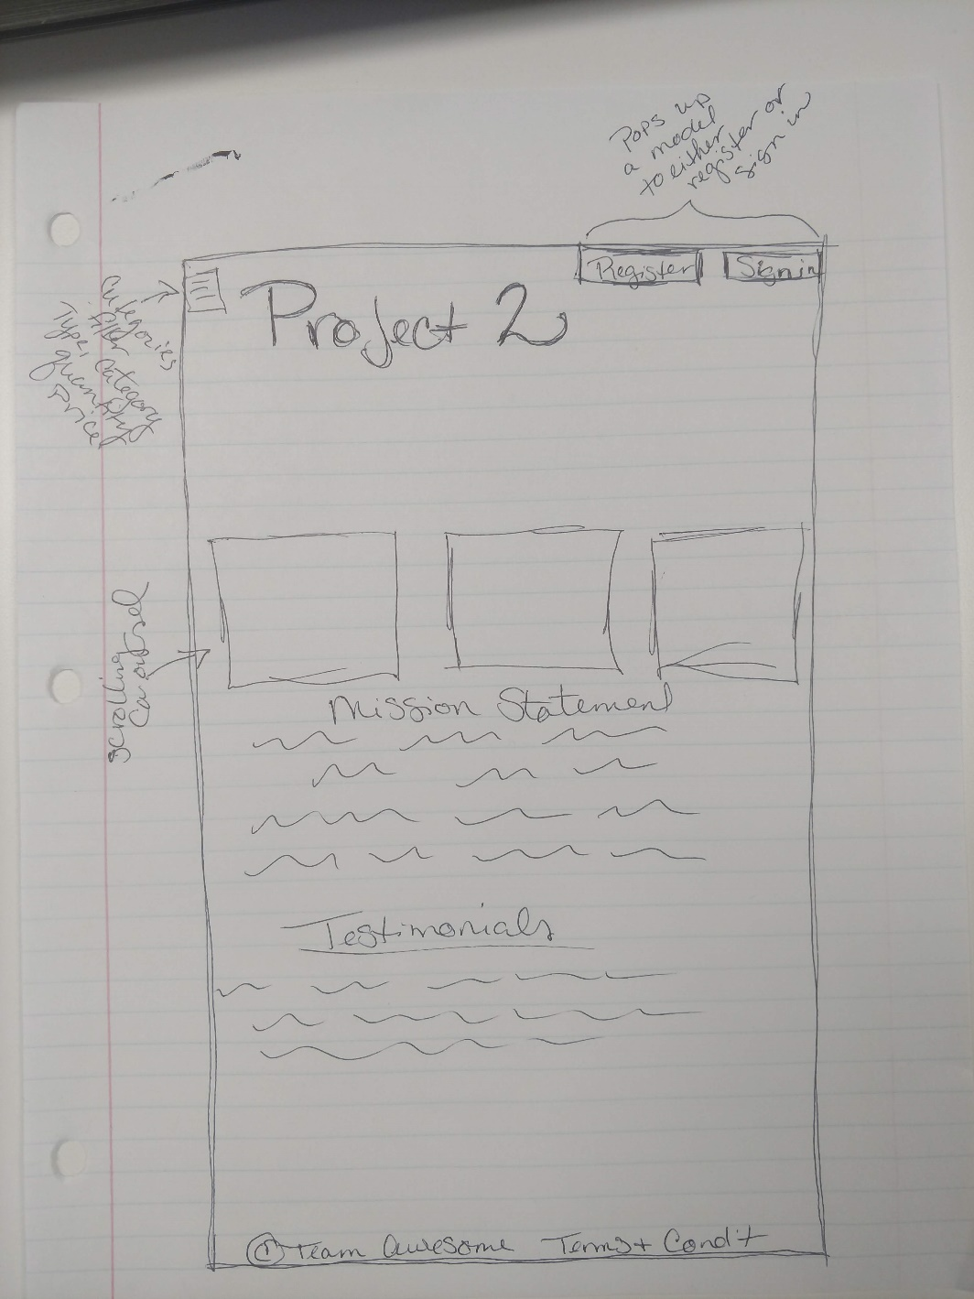
* We are planning on using Google Maps API. Possibly more…..
* Anthony F-Authentication, Sign in
* Talahoun- Database, routing
* Anthony M and Emma-Front End design.